Requirements Speciﬁcation

**Project Name**

Blackfoot Language Preservation

**Prepared by**

Blackfoot Language Preservation Group

**Date**

24 September 2020

You did a really nice job with this phase of the project, particularly the efforts you put forward to collect user feedback. I only wish it was summarized here so we could see and discuss it!



# Introduction

The Blackfoot Language Preservation Group has prepared this document to provide a detailed outline of the Blackfoot Language Preservation project requirements. This document includes a thorough look into:

* + The system’s diﬀerent user groups, their priorities, and individual tasks that they will be performing through this project.
  + Where, when, and how the system will be used.
  + The feedback gathered from the various user groups regarding the existing system and the extensions to the system that are being created.
  + The project's speciﬁc functional requirements and speciﬁcations, along with any

non-functional constraints, software, and hardware requirements.

# User Overview

The users of the Blackfoot Language Preservation Project can be divided amongst ﬁve diﬀerent user types, each with separate tasks to perform and concerns needing to be addressed in the ﬁnal product. These ﬁve user groups are as follows:

**Researchers:** Researchers will utilize the system to access all of the data being generated by other user groups. This includes the rendering of Microsoft Excel reports revealing the eﬀectiveness in learner pronunciation of speciﬁc words and the overall pronunciation ratings across all words to reveal trends. Researchers will also be able to upload audio segments to the service to allow for previously gathered audio data to be ingested into the system.

**Native Speakers:** Native speakers are the user group tasked with listening to and critiquing the audio pronunciations being generated by the language learners. This information should then be presented to the student to receive direct feedback, the teachers to gauge their students' performance, and the researchers so they can get a broad overview of the data.

**Language Learners:** The lowest level users of our system are the language learners, who will use the system for a few simple tasks. This includes recording/uploading audio, sharing audio, and viewing past submission comments/ratings.

**Language Teachers:** Teachers will be creating and managing classes of learners in the software to review student progress towards learning goals. Using the system, they will be able to view the Native speakers' critiques on their students' pronunciations.

**Administrators:** The administrators are the highest user group level, whose primary function is to manage the web service's day-to-day running. Their responsibilities include maintaining the server's database, operating the web server and host machine, and addressing any concerns raised by the other user groups.

# Hierarchy Chart of Users

Our hierarchy chart begins with Dr. Mizuki Miyashita, as she is the progenitor of this project/website. Researchers are one step below Dr. Miyashita but functionally will be using the website in the same way. Learners, Native speakers, and teachers branch from researchers because they will learn of the website most likely from researchers. Learners, Native speakers, and teachers each have their own blocks because they will each use the website in a diﬀerent way and for diﬀerent results.

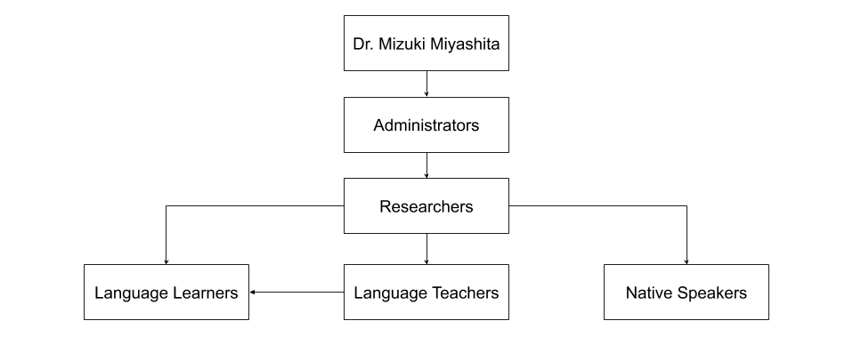

# User Groups

The table below lists the types of users as well as the number of users of that type and a detailed description for each user type.

|  |  |  |
| --- | --- | --- |
| User Type | Number | Description |
| Researcher | 1-5 | Researchers are gathering and using all of the data collected. As well as editing and reviewing audio. Researchers have advanced security privileges that allow them to view and |

|  |  |  |
| --- | --- | --- |
|  |  | edit the data of language learners and Native language speakers. Researchers will use features to view and edit data from language learners and Native language speakers.  Researchers may not have extensive knowledge of computer systems. Researchers may use the system several times a day mainly to view data to then later analyze. |
| Native Language Speaker | 5 | Native language speakers are ﬂuent speakers of the Blackfoot language who will be using the tool to listen to and rate audio recordings of Blackfoot words. A Native speaker's access level would be that of a guest user as the research does not require non-repudiation on their part. Native language speakers will also not be using the system more than several times a week per speaker. |
| Language Learner | 30 per class | Language learners are students who are learning the Blackfoot language. They will be using the tool to record and upload audio recordings of spoken Blackfoot words. A language learner's access level would be that of a regular user, requiring them to log in to the system and keep track of their recordings. |
| Language Teacher | 1-3 per class | Language teachers are teachers of the language learners and need to view the students’ rating data and respond to and rate the students’ submissions in their class. Language teachers will access the system up to 20 times a day to check their class’s data. Language teachers may not have extensive knowledge of computer systems. A language teacher's access level would allow them to view and respond to all of the language learners in their class. |
| Administrator | 2 | Administrators will maintain the service’s database and troubleshoot any bugs/concerns that come up after the product’s deployment. Administrators will also manage users of the system, adding and removing users as necessary. Administrators will have the highest access level. |

# User Feedback

The team’s preference for collecting feedback from language learners and Native speakers was an online survey. We determined that this was a feasible solution to collect feedback while staying safe from COVID-19. In our survey, we asked questions ranging from user experience

with technology to scenarios using images of the website, asking what the user would do. No personal information was collected in the surveys.

Throughout this process, the team received thirty-four responses from students and one response from a Native speaker. The responses from the survey informed the team on which devices are most utilized when browsing the web, how well users perceived the presentation of the existing website, and identiﬁed some misleading and confusing UI elements. The team can use this feedback to design a better user interface that requires less of a learning curve to use and is more productive for all user groups.

From the feedback received, the team has learned that students almost evenly and exclusively utilize mobile and laptop devices when browsing the web; from this information, the team learned that the user interface will need to accommodate smaller screen sizes. The feedback also revealed that the existing user registration page, while easy to use, needs further polishing in terms of its aesthetics.

See Appendix A - Language Student Survey for a copy of the language student survey used. See Appendix B - Native Speaker Survey for a copy of the Native language speaker survey used.

# Functional Requirements

Functional requirements are requirements that deﬁne basic system behavior. Below is a table of the functional requirements for the project. The requirements are ordered by the requirement group and priority level. For an explanation of the letters and numbers in the left-most column, see Appendix D - Key to Requirements Labeling.

|  |  |
| --- | --- |
| **(A) Administrators** | |
| A.H.1 | Administrators should be able to add and remove users from the other user groups. |
| A.H.2 | Administrators should be able to backup and restore all of the audio ﬁles stored on the web server. |
| A.H.3 | Administrators should be able to perform all functions that any other user type can perform (researchers, language learners, Native language speakers, and teachers). |

|  |  |
| --- | --- |
| A.M.1 | Administrators should be able to approve the registration of researchers and teacher accounts. |
| **(R) Researchers** | |
| R.H.1 | Researchers should be able to record and upload audio clips of Blackfoot words being spoken. |
| R.H.2 | Researchers should be able to upload previously gathered data including excel sheets, audio ﬁles, acoustic measurements, and word ratings. |
| R.H.3 | Researchers should be able to download data on acoustic measurements and word ratings into comma-separated or Excel spreadsheet ﬁles. |
| R.H.4 | Researchers should be able to view all existing data they are involved with and sort that data by ﬁlename, date created, score, speaker, evaluator, and word. |
| R.H.5 | Researchers should be able to view graphs showing the average rating for a particular: spoken word, student, Native speaker, and language being spoken. |
| R.H.6 | Researchers should be able to provide a unique link to a Native language speaker that allows the speaker to rate an audio clip without logging in to the website. This unique link is meant to be used by only one Native language speaker for |
| R.M.1 | Researchers should be able to trim large audio ﬁles into smaller audio ﬁles by selecting a portion of the large audio ﬁle and saving that portion as a smaller ﬁle. |
| R.M.2 | Researchers should be able to search or ﬁlter data by the word and language spoken in the audio recordings. |
| R.L.1 | Researchers should be able to launch the PRAAT software application from the site or use integrated PRAAT mechanics on the site. |
| R.L.2 | Researchers should be able to import the output of a PRAAT session into the system’s database. |
| **(N) Native Language Speakers** | |
| N.H.1 | Native language speakers should be able to rate audio ﬁles on a scale of 1 to 5 regarding the accuracy and quality of audio pronunciations. |
| N.H.2 | Native language speakers should be able to access and rate an audio ﬁle without a login. |

|  |  |
| --- | --- |
| N.M.1 | Native language speakers should be able to leave written comments on a particular student’s audio recording. |
| N.L.1 | Native language speakers should be able to leave audio comments on a particular student’s audio recording. |
| N.L.2 | Native language speakers should be able to record prompts for teachers to use in assignments. |
| **(T) Teachers** | |
| T.L.1 | Teachers should be able to establish classes and approve the joining of students’ into those classes. |
| T.L.2 | Teachers should be able to access the ratings of individual students in their classes. |
| T.L.3 | Teachers should be able to create assignments for students using recorded prompts or text. |
| T.L.4 | Teachers should be able to rate students’ audio recordings in terms of the pronunciation’s correctness. |
| T.L.5 | Teachers should be able to create a recording of themselves telling a story in a speciﬁc language to which students may listen. |
| **(S) Students** | |
| S.H.1 | Students should be able to record and upload audio clips of spoken words. |
| S.H.2 | Students should be able to provide a text description to accompany their recorded audio. |
| S.H.3 | Students should be able to view the ratings and feedback of only their audio clips. |
| S.M.1 | Students should be able to listen to their pronunciations in their recorded audio ﬁles. |
| S.L.1 | Students should be able to listen to a Native language speaker’s pronunciation of a given word. |
| S.L.2 | Students should be able to view any additional written comments associated with their particular student audio recording. |
| **(D) Database** | |

|  |  |
| --- | --- |
| D.H.1 | The database should be able to associate an audio ﬁle with the user who uploaded the audio ﬁle. |
| D.H.2 | The database should be able to associate ratings with the audio ﬁles. |
| D.H.3 | The database should be able to backup all the data stored in the database. |
| D.L.1 | The database should be able to associate all students with their respective classes. |
| D.L.2 | The database should be able to associate teachers with their respective classes. |
| D.L.3 | The database should be able to support words from multiple languages. |
| **(W) Website** | |
| W.H.1 | The website should be able to register new users to the system by the user group. |
| W.H.2 | The website should be able to login all of the diﬀerent users using an email address and a secure password. |
| W.H.3 | The website should be able to show diﬀerent pages and functions depending on the logged-in user’s group. |

# Non-functional Requirements

Non-functional requirements refer to the functions necessary to support the system and the performance guarantees of the system. The table below is sectioned by the requirement group and then the priority level. For an explanation of the letters and numbers in the left-most column, see Appendix D - Key to Requirements Labeling.

|  |  |
| --- | --- |
| **(RN) Researcher Non-Functional** | |
| RN.H.1 | The system should be able to support the Blackfoot alphabet. |
| RN.L.1 | The system should be able to distinguish between diﬀerent dialects in audio recordings. |
| RN.L.2 | The system should be able to distinguish between diﬀerent dialects in audio recordings. |

|  |  |
| --- | --- |
| **(WN) Website Non-Functional** | |
| WN.H.1 | The system should have easy-to-use functionality for all platforms. |
| WN.H.2 | The system should be as bug-free as possible so major functionalities are not adversely aﬀected. |
| WN.H.3 | The system should be free of any data vulnerabilities that would allow user data to be exposed. |
| WN.M.1 | The system should comply with all University of Montana “Disability Services for Students” requirements and policies. |
| WN.M.2 | The system should prepare audio ﬁles for raters within 1 second of requesting the data. |
| WN.M.3 | The system should be able to send a download of ratings in less than 2 minutes on a web connection of 1 Mb/s or higher. |
| WN.M.4 | The system should be easy to maintain and code should be easy to read so future developers can easily pick up the project. |

# Hardware Requirements

Hardware requirements for the project are outlined in the table below and ordered by priority level. For an explanation of the letters and numbers in the left-most column, see Appendix D - Key to Requirements Labeling.

|  |  |
| --- | --- |
| **(HW) Hardware** | |
| HW.H.1 | The web server should be able to support up to 5 gigabytes of audio ﬁles. |
| HW.H.2 | The web server should be able to support 40 simultaneous users. |
| HW.H.3 | The web server should backup the server data in an automatic weekly process. |
| HW.M.1 | The web server should have a 99.9% server up-time, with the remaining 0.1% being for reboots and updates. |

# Software Requirements

Software requirements for the project are outlined in the table below and are ordered by priority. Note: this section only contains high priority requirements. For an explanation of the letters and numbers in the left-most column, see Appendix D - Key to Requirements Labeling.

|  |  |
| --- | --- |
| **(SW) Software** | |
| SW.H.1 | The website should be accessible from Microsoft Windows (XP and later) and macOS (X and later) operating systems. |
| SW.H.2 | The website should be accessible on Google Chrome, Microsoft Edge, Microsoft Internet Explorer, Mozilla Firefox, Safari, and Opera web browsers. |

# Execution and Acknowledgement

The team members hereby indicate by their signatures below that they have read and agree with the speciﬁcations of this document.

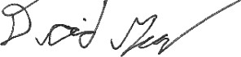

4 OCT 2020 4 OCT 2020

Team Member / Date Team Member / Date



4 OCT 2020 4 OCT 2020

Team Member / Date Team Member / Date

Client Name / Date

# Appendix A - Language Student Survey

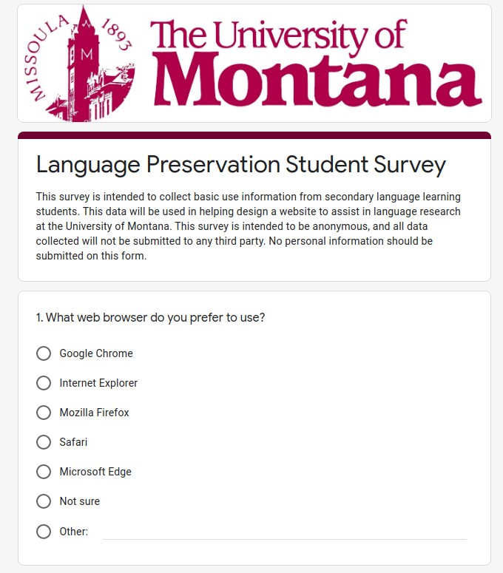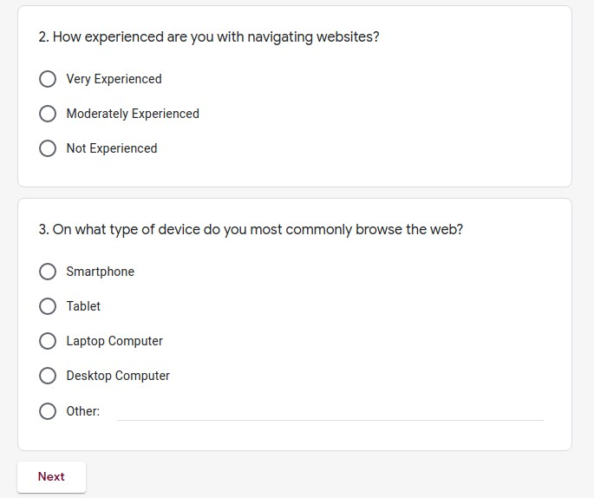

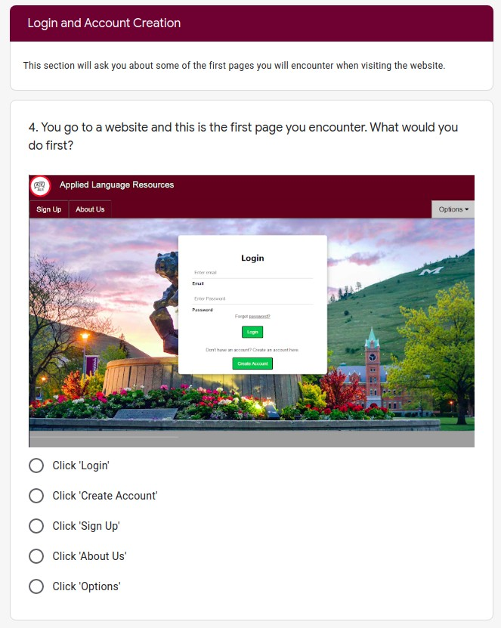 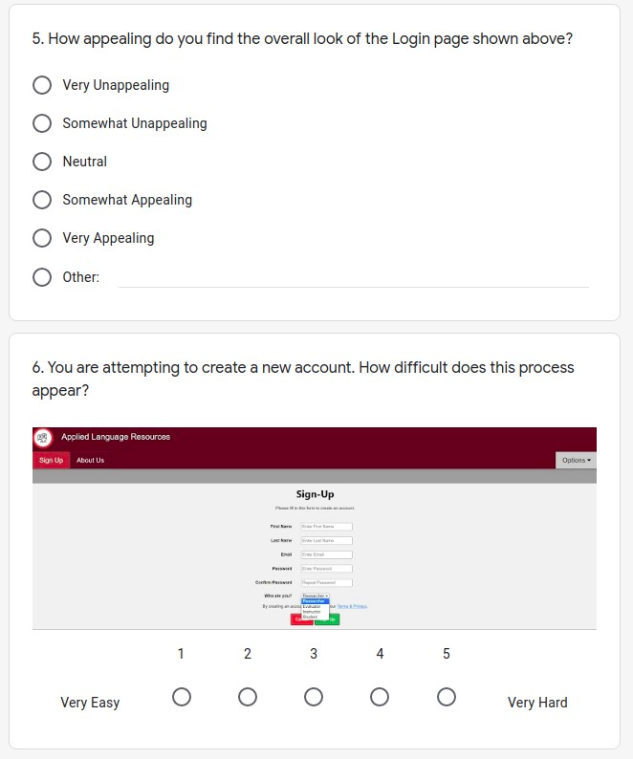

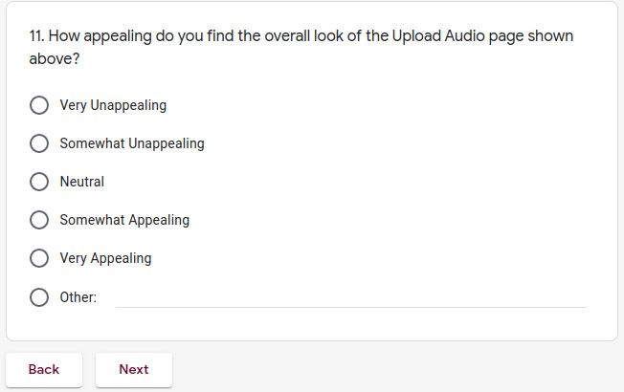

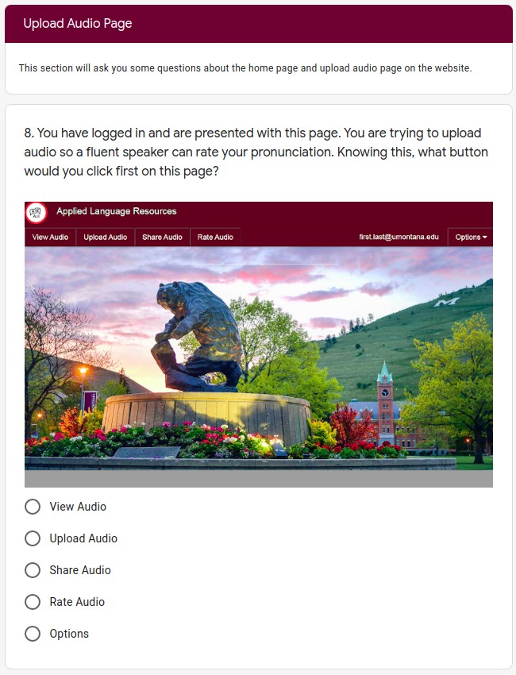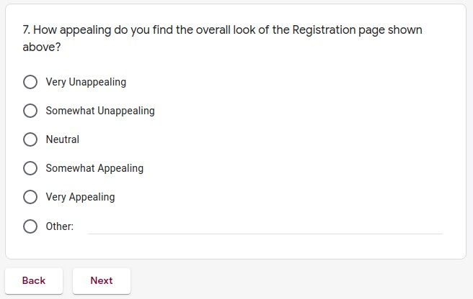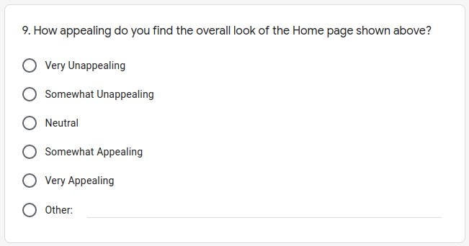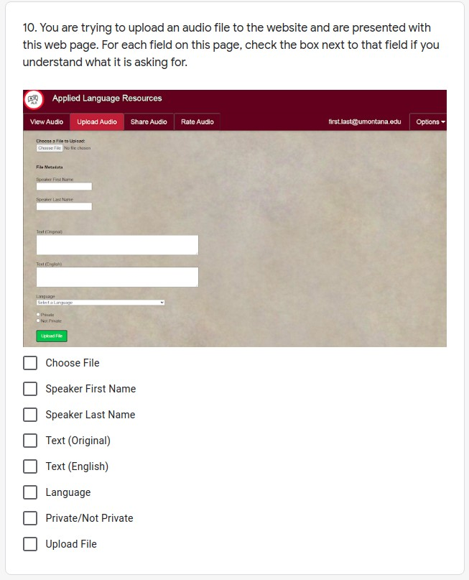

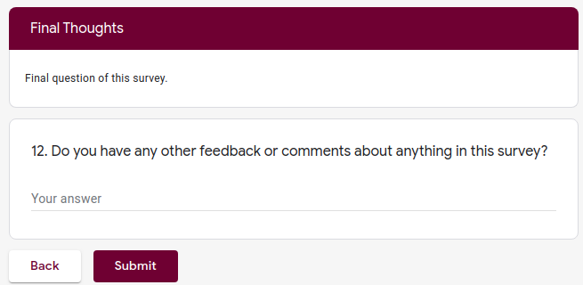

# Appendix B - Native Speaker Survey

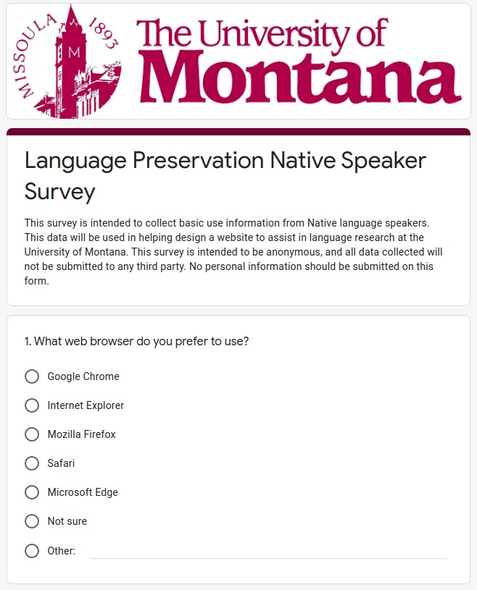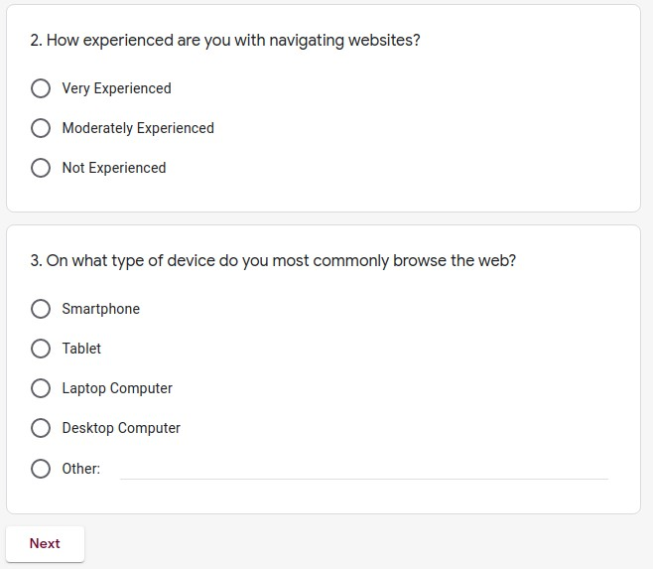

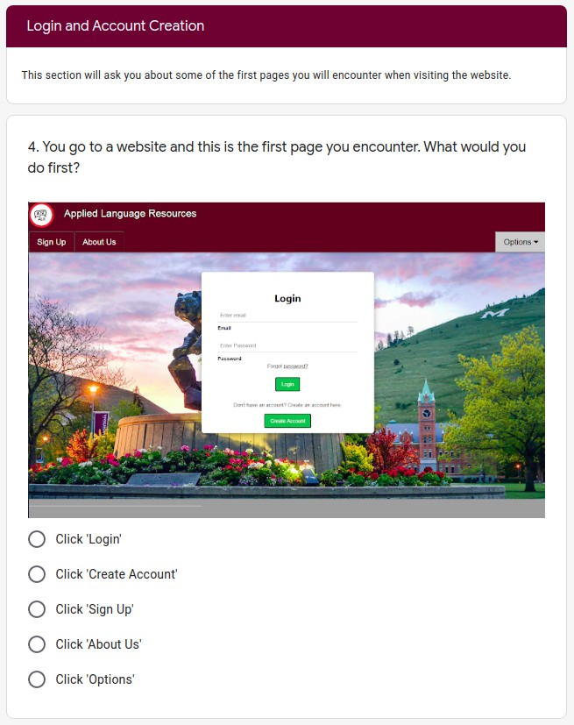 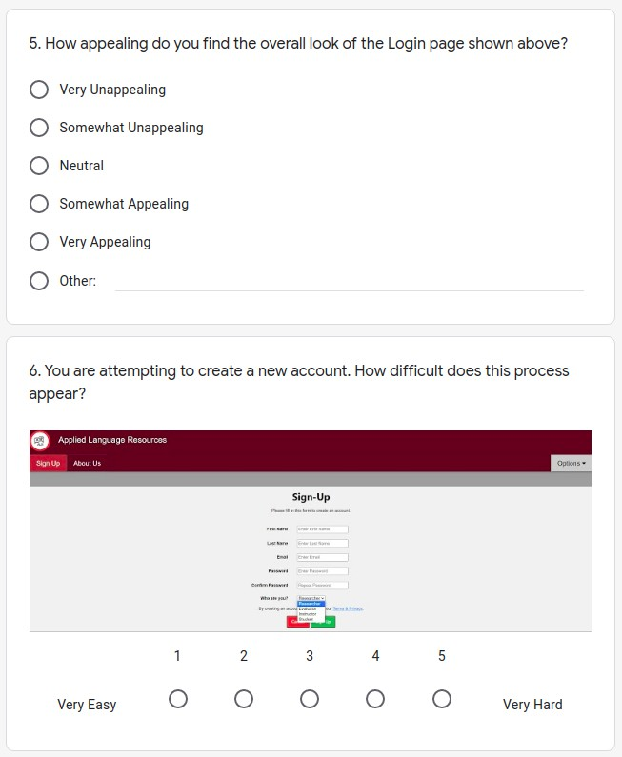

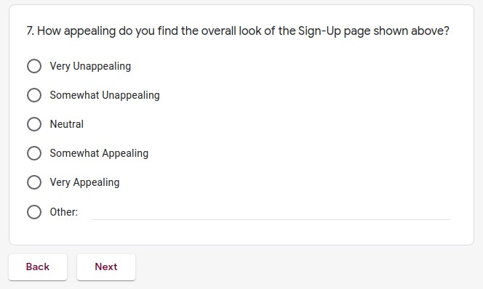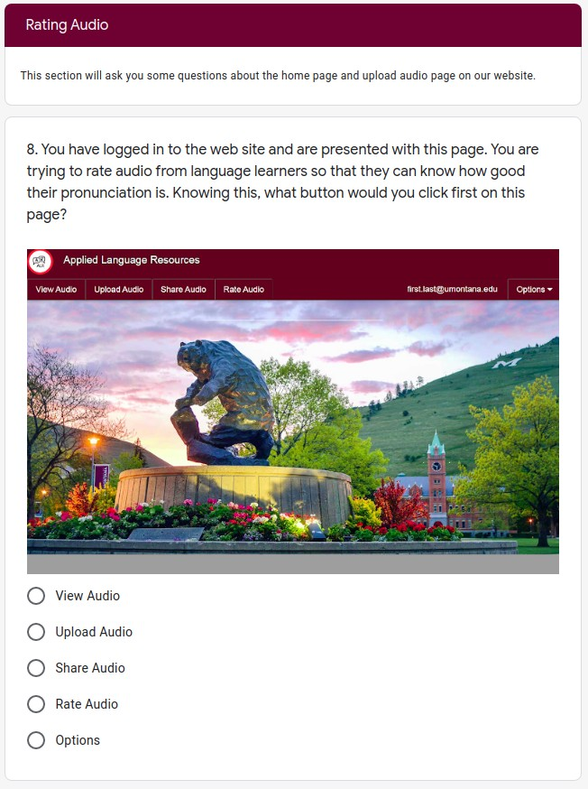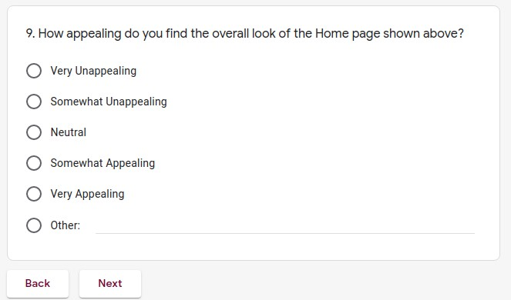

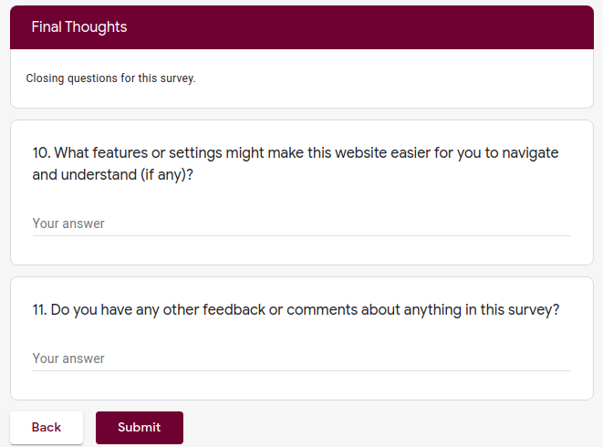

# Appendix C - Ethics Course Certiﬁcates



 



# Appendix D - Key to Requirements Labeling

User or Function Code . Priority . Requirement Number

|  |  |  |
| --- | --- | --- |
| User or Function Code | Priority Level | Requirement Number |
| A: Administrators | H: High priority (necessary for basic program functionality) | #: Number for ordering |
| D: Database | L: Low priority (implemented after all high and medium priority requirements) |  |
| HW: Hardware | M: Medium priority (not necessary for basic program functionality) |  |
| N: Native language speakers |  |  |
| R: Researchers |  |  |
| RN: Researchers (non-functional) |  |  |
| S: Students |  |  |
| SW: Software |  |  |
| T: Teachers |  |  |
| W: Website |  |  |
| WN: Website (non-functional) |  |  |